How to record with a video embedded in your PowerPoint presentation

Version 1.01 – March 2022

Embedding a video in a PowerPoint presentation
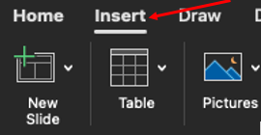
- To insert a video, click on the “Insert” panel.

- Click on “Video”.
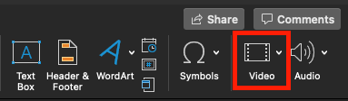
- If you would like to insert a video which is already on your computer, click on “video from file”, and select the video you would like to embed.

If you would like to insert a video from the internet, select “online film” and past the link into the text box.

- With the video selected, navigate to the “Playback” panel, and choose when you would like the video to start.

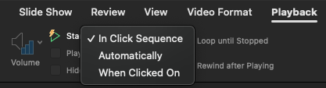

In Click Sequence: Starts the video as you click to progress.

Automatically: Starts the video when you begin the slide.

When Clicked on: Starts the video when you click on the video.

Preparing your Rapidmooc to record

- With your presentation open and your device connected to the HDMI PC port, open the Rapidmooc application and select “Record video”
- Select your desired video mode.
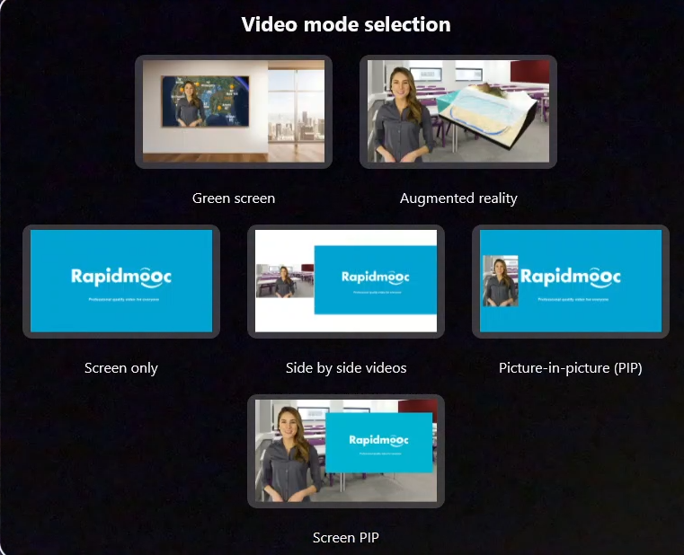

- Enable and adjust the necessary audio inputs by navigating to “Settings” > “Microphones”.
N.B., Red indicates an input is disabled, and green indicates an input is enabled.

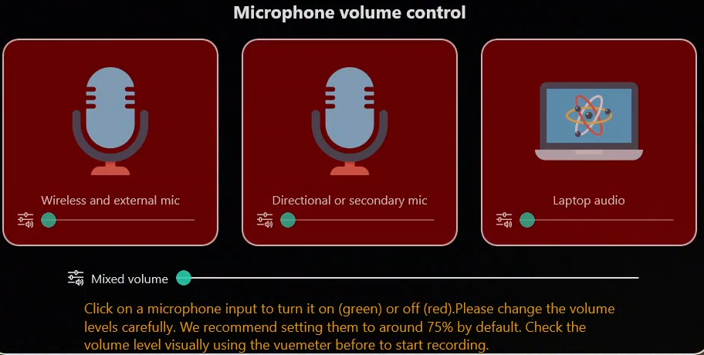

- Perform a test recording to ensure the audio levels are satisfactory and make any necessary adjustments.
- When you’re ready, record your video.

