Installing and setting up the BOYA microphones set

Table of contents
Introduction 2
Contents of the microphones set 2
Connecting the receiver 3
Pairing the transmitter and the receiver 3
Adjusting the volume 4
Additional settings 4

Introduction
This new kit replaces the Rodes Filmmaker microphones that were supplied to date. The BOYA microphones and receiver are much smaller and lighter than the old microphones.
A single receiver can manage both microphones. This facilitates their integration into the studio and their use by the speakers.

Contents of the microphones set
The BOYA kit consists of two transmitters and a receiver operating wirelessly on the 2.4Ghz frequency.
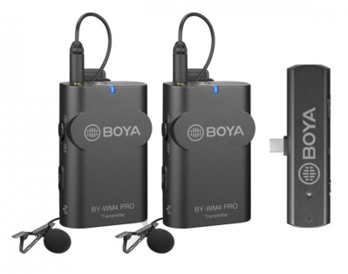
Transmitters

Receiver

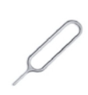
A pin is also provider for pairing the transmitters to the receiver:

Connecting the receiver
To avoid noise, you should not connect the USB-C directly to the pc inside the Rapidmooc studio but to a dedicated electrical outlet using the USB charger.
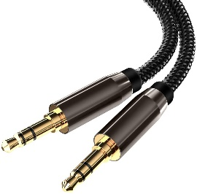
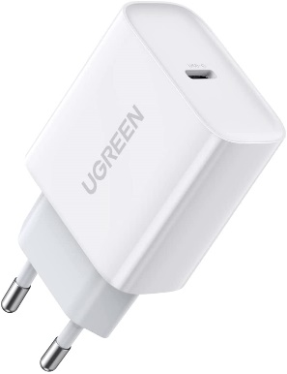
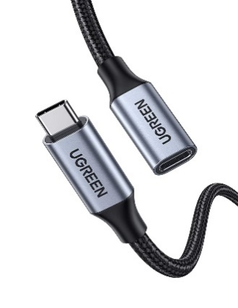
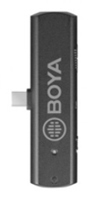

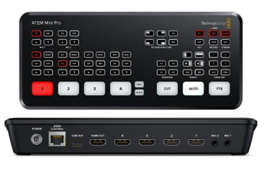

Pairing the transmitter and the receiver
- Connect the receiver to the usb-c charger to turn it on
- Long press the pair bottom of receiver with pair pin as below. The indicator of receiver will flash quickly when entering pairing mode.
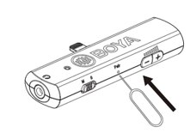
- Long press the pair button on the side of the transmitter to enter in pairing mode.
When the transmitter and receiver are connected, the light of receiver stays blue and transmitter flashes every 2.5 seconds.

Adjusting the volume
The volume must be adjusted on the receiver. As there is no level meter, this should be done using the Rapidmooc application or, for greater accuracy, the Atem Software Control application.
It is preferable that this volume adjustment be performed by a Rapidmooc technician or with their support.
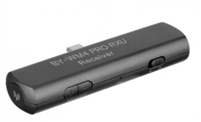

Additional settings
It is necessary to set the receiver to mono mode for the microphones to be recorded on both stereo channels.

To be set on M position

