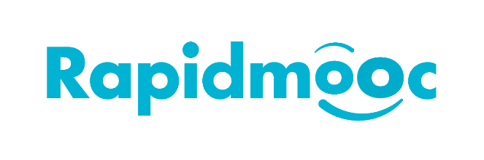

How to use the GoTo (Webinar / Meeting)

on your Rapidmooc

Intro
GoTo is a popular communication and collaboration solution for online meetings, webinars and training.

Setting up the Rapidmooc application
Before using GoTo, it is necessary to set up the Rapidmooc application to work with it.
From the Rapidmooc App homepage, click on the “Settings” button as below:
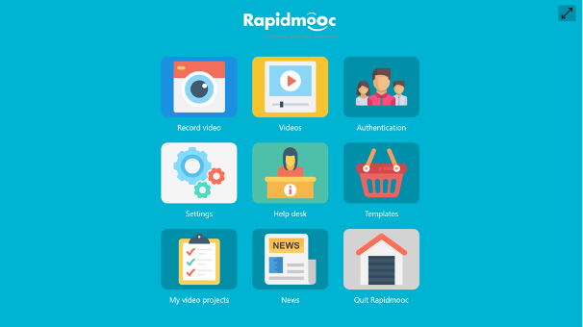
Then select the “Web Meeting platform” menu and set the default meeting platform to “GoToMeeting / GoToWebinar”. Then click on “Save” button and leave the settings screen.
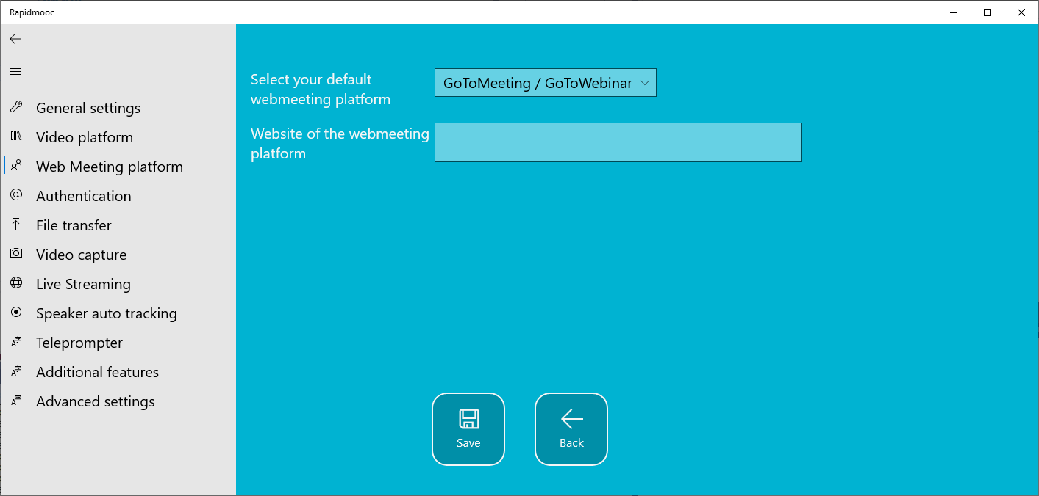

Important: quit the Rapidmooc application and start it again so that the settings can be applied.
Back on the home screen, click on the "Record video" button.
Select the video mode or template that you want to apply in GoTo then click on the top right button to leave full screen:
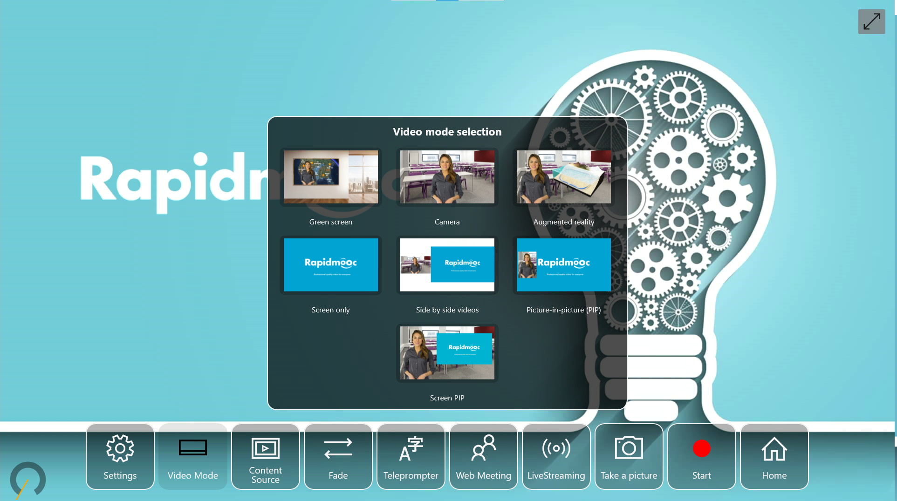
The Rapidmooc application will be displayed in a minimized window as below:
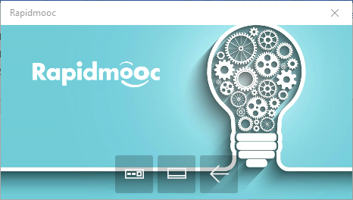
From this window, you will be able to change the video mode or the camera during the webinar

Setting up the GoToWebinar / GoToMeeting application
From the desktop or from a browser, launch the GoTo application and connect to your meeting. Then click on the “Settings” button to open the preferences window.
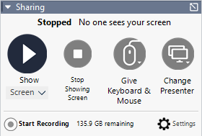
In the Preferences window, select the Audio category and then set the microphone to “Microphone (USB Capture HDMI+ Mic)
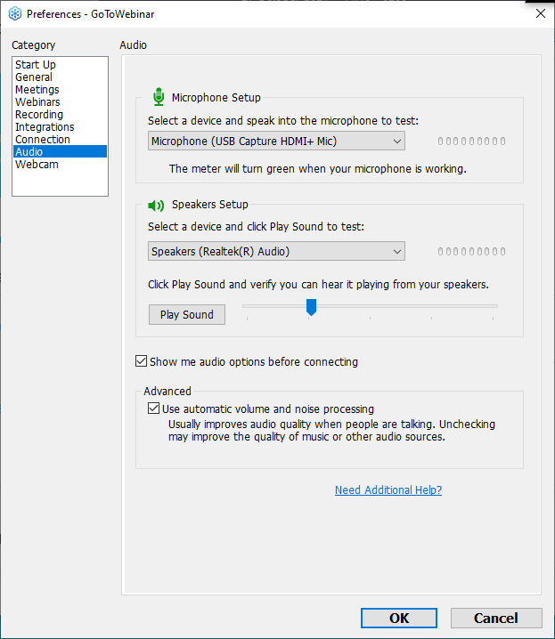
Leave the speaker setup to the default speaker.
Then select the Webcam category and set the camera to “USB Capture HDMI+” as below. Also set the display format to 16:9.
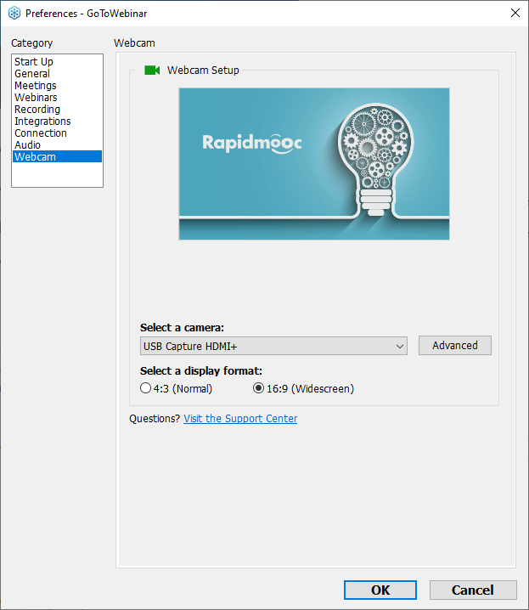
Click the OK button to save your changes and start your webmeeting whenever you’re ready.

