How to correctly setup use augmented reality

Version 1.01 – October 2021

Formatting your PowerPoint for augmented reality
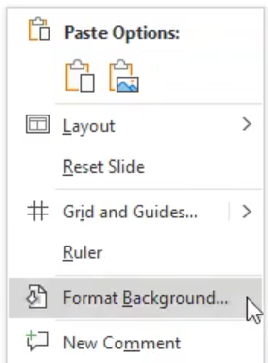
- Format the background of your PowerPoint by right clicking on the PowerPoint slide and selecting “Format Background”.

- Click on the pain bucket and click “more colours”.

- Click on “custom” and set Red and Blue to 0 and Green to 255

- Add any additional elements to your presentation, save your PowerPoint and connect your device to the HDMI PC port

Setting up augmented reality in the Rapidmooc application
- With your presentation open and your device connected to the HDMI PC port, open the Rapidmooc application and select “Record video”
- Click on “Video mode” and select “Augmented reality”
- Select “Content source” and make sure the source “Laptop” is enabled. N.B., when a source is enabled, the box surrounding the source will be highlighted in green.
- Proceed to check if your camera framing and audio sources are correct.
- When you’re ready, record your video.

