Quick troubleshooting: Camera control not working

If the Rapidmooc camera can no longer be operated via the app ("Settings" => "Camera position") with the arrow keys, we suggest the following procedure via the Windows device manager. In most cases, the operation of the camera can be restored using the Rapidmooc app.
- Quit the Rapidmooc app and move to the Windows user interface.
- Open device manager by right clicking on the windows logo on the bottom left of your screen. You can also find it under "Start" using the windows search function.

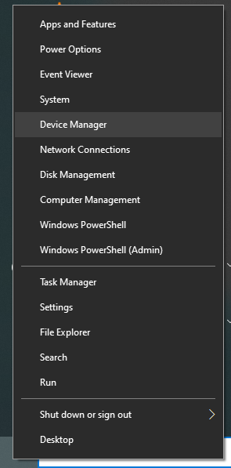
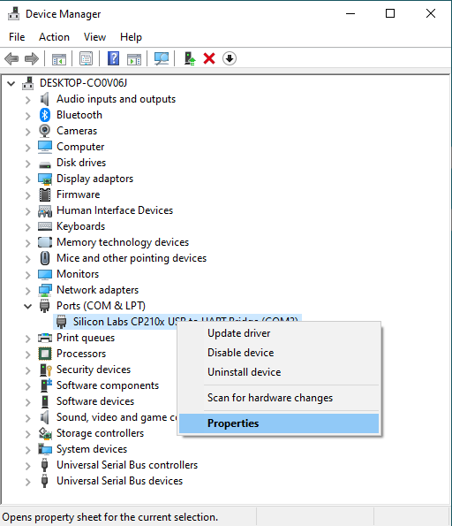

- Expand the "Ports (COM & LPT)" item in the device manager.
- Then select “Silicon Labs” with a right click and select “Properties”.

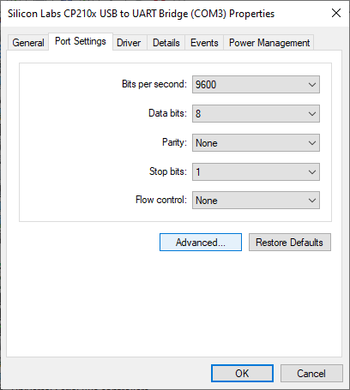
- Now open the "Advanced Settings", apply the following settings and then press OK.
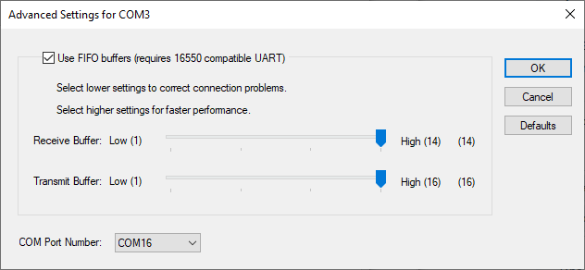

After completing the aforementioned steps, restart the Rapidmooc application and check whether the camera can be controlled again via the corresponding control panel. If the camera control functionality is not fully restored, check the Windows settings again, restart the entire PC and test the camera function again via the Rapidmooc app.

